While mvn : complie test or while performing the mvn test from eclipse can throw the following error:

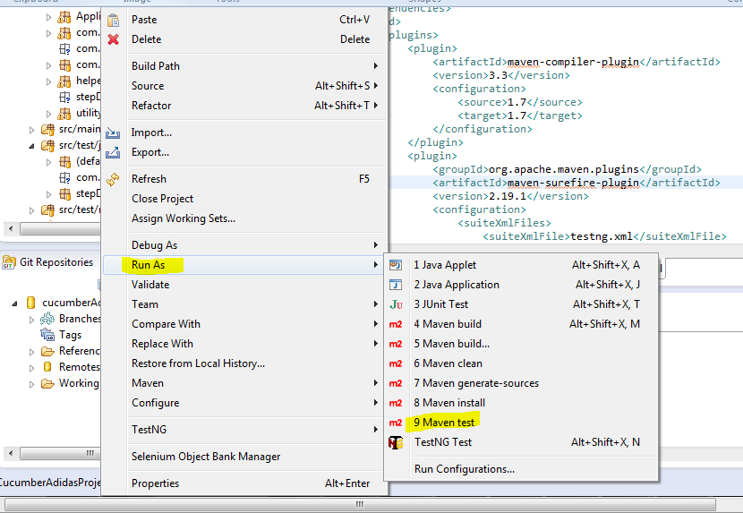

Error:

[INFO] -------------------------------------------------------------

[ERROR] COMPILATION ERROR :

[INFO] -------------------------------------------------------------

[ERROR] /C:/Users/hiteshg/git/cucumberAdidas3_03292018/cucumberframework/src/main/java/Application_Pages/Adidas_Home_Page.java:[11,18] package org.testng does not exist

[ERROR] /C:/Users/hiteshg/git/cucumberAdidas3_03292018/cucumberframework/src/main/java/helpers/Hook.java:[13,30] package org.testng.annotations does not exist

[ERROR] /C:/Users/hiteshg/git/cucumberAdidas3_03292018/cucumberframework/src/main/java/Application_Pages/Adidas_Home_Page.java:[116,25] cannot find symbol

symbol: variable Assert

location: class Application_Pages.Adidas_Home_Page

[ERROR] /C:/Users/hiteshg/git/cucumberAdidas3_03292018/cucumberframework/src/main/java/Application_Pages/Women_TShirt_Page.java:[211,17] cannot find symbol

Resolution:

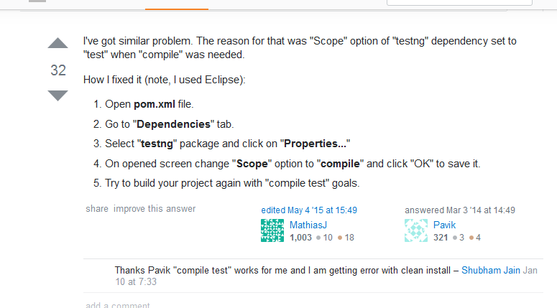

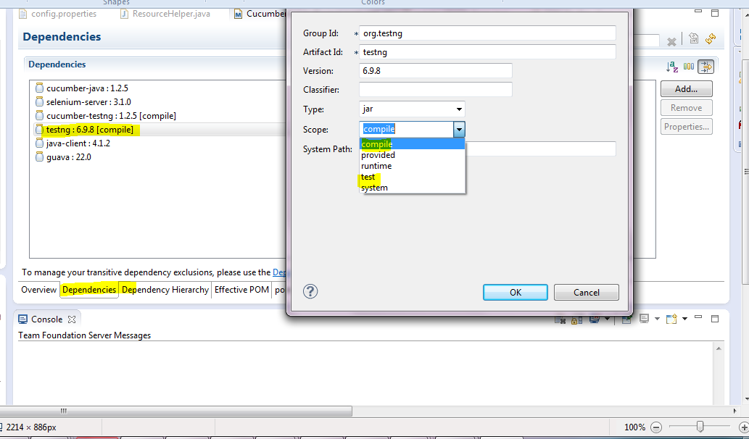

Also, add the ‘compile’ scope in the following dependency if it is missing as stated in the following screen shots in pom.xml

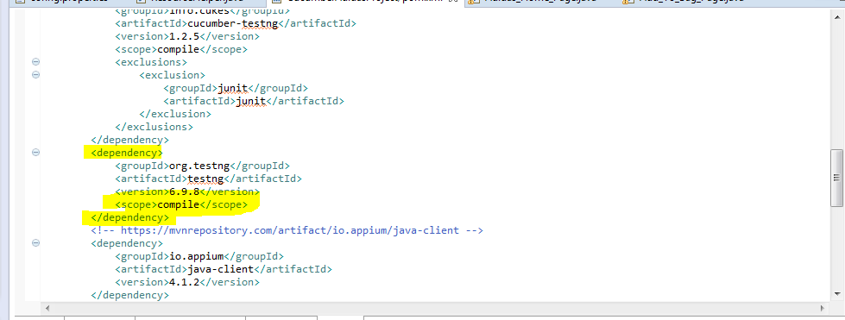

Errors were removed and I was able to compile and test the test cases successfully.

Note: Steps to follow in sequence:

First step: First Maven🡪Clean: It will clean the build i.e. It will clean the target forget. That must be the first step.

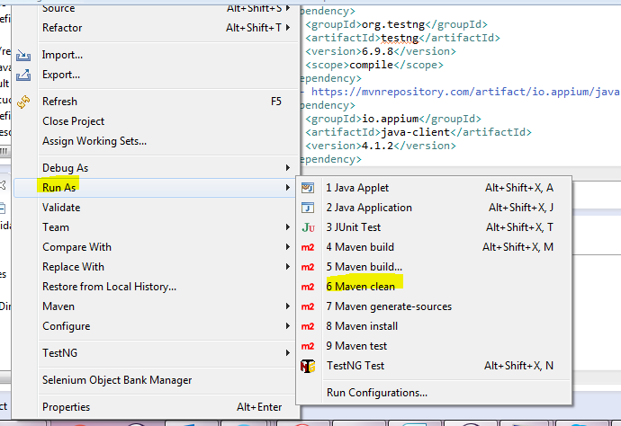

Second step: Then Maven🡪Test to run the test cases defined in testng.xml

